1. Model to generate a new table with only the types column and an associated ID.

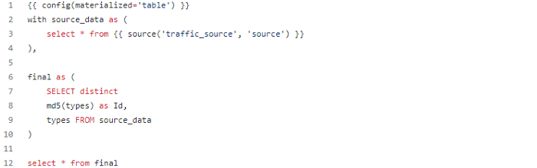
2. Model to create a new table from traveled_d and avg_speed columns of our data
